SmartRetail Vision: AI-Powered Autonomous Inventory Monitoring and Shelf Analytics
CO3 Assessment Tool 2 – Code Review & Repository Evaluation
1. Problem Overview
1.1 Introduction
The retail industry increasingly depends on automation and data-driven decision-making to improve operational efficiency and customer satisfaction. Traditional inventory management methods involve manual shelf inspections, which are time-consuming, error-prone, and expensive.
Retail stores frequently face stock shortages, overstocking, misplaced products, empty shelves, and delayed inventory updates. Manual inventory audits also fail to provide continuous, real-time visibility into shelf conditions.
SmartRetail Vision is an AI-powered autonomous inventory monitoring and shelf analytics system designed to address these challenges. The system uses computer vision, deep learning, and inventory analytics to monitor retail shelves and identify product availability, missing products, misplaced items, and shelf-level anomalies.
The proposed system provides a centralized platform through which retail managers can monitor shelf conditions, receive inventory alerts, analyze shelf utilization, and use historical data to support demand prediction and replenishment decisions.
1.2 Problem Statement
Retail stores experience financial losses because of stockouts, overstocking, incorrect product placement, and delayed inventory updates. Existing inventory systems commonly depend on barcode scanning and periodic stock verification, which cannot continuously detect shelf-level problems.
Therefore, SmartRetail Vision aims to automate inventory monitoring through AI-based shelf image analysis. The system continuously analyzes shelf information, identifies inventory anomalies, generates alerts, and provides analytics to support better inventory and merchandising decisions.
1.3 Objectives
The major objectives of SmartRetail Vision are:
- To develop an AI-powered computer vision system for real-time shelf monitoring.
- To detect stock shortages, misplaced items, and empty shelves automatically.
- To analyze shelf images using deep learning object detection models.
- To generate real-time alerts for inventory replenishment.
- To provide analytics on product visibility and shelf utilization.
- To predict inventory demand using historical sales and shelf data.
- To integrate with existing retail inventory management systems.
- To improve operational efficiency through automated inventory tracking.
1.4 Key Functionalities
The major functionalities of the proposed system include:
- User authentication and access management.
- AI-based shelf image analysis.
- Product detection and identification.
- Empty shelf detection.
- Stock shortage detection.
- Misplaced product detection.
- Inventory anomaly identification.
- Automated replenishment alerts.
- Shelf utilization analytics.
- Product visibility analytics.
- Historical inventory analysis.
- Demand prediction.
- Inventory system integration.
- Reporting and administration.
1.5 Implemented Solution
SmartRetail Vision follows an automated workflow in which shelf information is captured and analyzed using computer vision and deep learning techniques. Detected products and shelf conditions are processed by the application to identify inventory problems.
The processed information is presented through a dashboard so that retail managers can monitor inventory status and receive actionable information. When stock shortages or other anomalies are identified, the system can generate alerts to support timely replenishment.
Historical inventory and sales information can also be used for analytics and demand prediction. This enables the system to move beyond simple inventory tracking toward intelligent retail decision support.

2. Repository Organization
2.1 Repository Structure
The SmartRetail Vision project is organized into separate components so that application functionality can be developed and maintained systematically.
A recommended repository organization for the project is:
SmartRetail-Vision/
│
├── frontend/
│ ├── src/
│ ├── components/
│ ├── pages/
│ ├── assets/
│ └── package.json
│
├── backend/
│ ├── routes/
│ ├── controllers/
│ ├── models/
│ ├── services/
│ └── server.js
│
├── ai-model/
│ ├── dataset/
│ ├── training/
│ ├── inference/
│ └── model/
│
├── database/
│ └── schema/
│
├── docs/
│ ├── architecture/
│ └── screenshots/
│
├── tests/
│ ├── unit/
│ └── integration/
│
├── README.md
├── requirements.txt
├── package.json
└── .gitignore
Screenshot to insert: GitHub repository main page showing the actual folder and file structure.
2.2 Folder Organization
The repository is divided according to the major responsibilities of the application.
- Frontend: Contains the user interface and dashboard components.
- Backend: Contains server-side logic, APIs, and business operations.
- AI Model: Contains the computer vision and deep learning components.
- Database: Contains database-related configurations and schemas.
- Documentation: Contains architecture diagrams, screenshots, and project documentation.
- Tests: Contains testing-related files.
- README.md: Provides project overview, setup instructions, and usage information.
This separation makes it easier for developers to locate relevant files and modify individual components without affecting unrelated parts of the project.
2.3 File Naming Conventions
Consistent naming conventions improve readability and maintainability. Files should use descriptive names based on their functionality.
Examples include:
- Dashboard.jsx
- InventoryTable.jsx
- AlertPanel.jsx
- productController.js
- inventoryService.js
- modelInference.py
- demandPrediction.py
Descriptive naming helps developers understand the purpose of a file without opening it.
2.4 Maintainability and Collaboration
The repository organization supports collaboration by separating frontend, backend, AI, database, and testing responsibilities. Different team members can work on separate components while Git provides version control for integrating their changes.
A modular repository structure also makes future enhancements easier. For example, a new AI detection model can be integrated into the AI module without requiring major changes to the user interface.

3. Code Quality Review
3.1 Readability
The code should be written using clear variable names, meaningful function names, consistent indentation, and appropriate comments.
Examples of readable naming include:
productCount
stockLevel
shelfStatus
detectedProducts
replenishmentAlert
Such naming makes the code easier to understand and reduces the time required for debugging and maintenance.
3.2 Modularity
SmartRetail Vision consists of several independent functional areas such as authentication, shelf monitoring, inventory detection, alerts, analytics, demand prediction, and reporting.
These functionalities should be implemented as separate modules rather than placing all functionality in a single file.
A modular implementation provides the following benefits:
- Easier debugging.
- Easier testing.
- Better code reuse.
- Easier team collaboration.
- Easier future modifications.
3.3 Coding Standards
The project should follow consistent coding practices throughout the repository. These include:
- Consistent indentation.
- Meaningful variable and function names.
- Avoidance of unnecessary duplicate code.
- Proper separation of frontend and backend logic.
- Reusable components.
- Appropriate comments for complex operations.
- Proper error handling.
3.4 Documentation in Code
Comments and documentation should be used where they provide useful information, especially for complex AI processing, database operations, and business logic.
However, excessive comments for self-explanatory code should be avoided. Documentation should explain why a complex operation is performed rather than simply repeating what the code does.
3.5 Strengths
The major strengths of the project include:
- Clear separation of major application functionalities.
- Use of modular components.
- Application of AI for automated inventory monitoring.
- Potential for real-time inventory analysis.
- Dashboard-based visualization.
- Automated anomaly and replenishment alerts.
- Scope for integration with existing inventory systems.
- Scalability for different retail environments.
3.6 Areas for Improvement
Possible areas for improvement include:
- Adding more comprehensive error handling.
- Increasing automated test coverage.
- Improving inline documentation.
- Applying consistent coding standards across all modules.
- Optimizing AI model inference performance.
- Improving database query efficiency.
- Adding stronger input validation.
- Implementing comprehensive logging.
- Improving security and access control.
Screenshot to insert: A representative source-code file showing readable, modular code.

4. Version Control Evaluation
4.1 Git Repository
Git is used to maintain different versions of the SmartRetail Vision project. It provides a history of modifications and allows developers to track changes made to the application.
The repository can also be hosted on GitHub to facilitate collaborative development.
GitHub Repository:
[Insert your GitHub repository link here]
4.2 Commit History
Commit history provides information about how the project evolved during development.
Good commit messages should clearly describe the change made.
Examples:
Initial project setup
Added dashboard interface
Implemented product detection
Added inventory anomaly detection
Added replenishment alerts
Updated README documentation
Added test cases
Fixed dashboard UI issues
Descriptive commit messages make it easier to identify changes and troubleshoot problems.
Screenshot to insert: GitHub commit history page.
4.3 Branching Strategy
A suitable branching strategy for the project is:
main
│
├── feature/frontend
├── feature/ai-model
├── feature/backend
└── feature/testing
The main branch should contain stable versions of the project, while feature branches can be used for independent development.
After development and testing, completed features can be merged into the main branch.
4.4 Repository Maintenance
Repository maintenance includes:
- Removing unnecessary files.
- Maintaining an appropriate .gitignore.
- Updating README documentation.
- Keeping dependencies organized.
- Using meaningful commit messages.
- Avoiding unnecessary duplicate files.
- Keeping stable versions in the main branch.
4.5 Collaboration
Git supports collaborative software development by allowing multiple developers to work on different parts of the project. Changes can be committed, reviewed, merged, and tracked.
For SmartRetail Vision, one developer can work on the frontend while another works on AI model integration or backend services. Git provides a controlled mechanism for combining these contributions.

5. Code Testing and Validation
5.1 Testing Objective
Testing is performed to ensure that SmartRetail Vision functions correctly and produces expected results.
The application should be tested at different levels, including:
- Functional testing.
- UI testing.
- AI model testing.
- Integration testing.
- Database testing.
- Error-handling testing.
5.2 Test Cases
Test ID | Test Case | Expected Result | Status
TC01 | User login with valid credentials | User successfully enters dashboard | Pass
TC02 | User login with invalid credentials | Error message is displayed | Pass
TC03 | Upload shelf image | Image is accepted for analysis | Pass
TC04 | Detect products from shelf image | Products are identified by AI model | Pass
TC05 | Empty shelf detection | Empty shelf is identified | Pass
TC06 | Stock shortage detection | Low-stock condition is identified | Pass
TC07 | Misplaced product detection | Incorrect product placement is detected | Pass
TC08 | Inventory alert generation | Replenishment alert is displayed | Pass
TC09 | Dashboard analytics | Inventory information is displayed correctly | Pass
TC10 | Invalid input | Appropriate validation/error message appears | Pass
Note: Update the status column to match your actual execution results.
5.3 Test Execution
Each test case should be executed using the implemented application. The actual output should be compared with the expected output.
Testing should confirm that:
- The application starts correctly.
- Users can access authorized functions.
- Shelf images can be processed.
- Products can be detected.
- Inventory anomalies can be identified.
- Alerts are generated appropriately.
- Dashboard information is displayed correctly.
5.4 Validation
The system is considered functionally successful when the major workflows execute without errors and the generated results correspond to the expected application behavior.
Screenshots to insert:
- Login/dashboard screen
- Shelf image analysis screen
- Product detection output
- Inventory anomaly alert
- Analytics dashboard
- Test execution results

6. Repository Documentation
6.1 README
The repository README should provide a clear overview of SmartRetail Vision and explain how a new developer can install and run the project.
The README should contain:
- Project title.
- Problem statement.
- Project objectives.
- Features.
- Technologies used.
- System architecture.
- Installation instructions.
- Configuration requirements.
- Usage instructions.
- Testing instructions.
- Screenshots.
- Repository information.
6.2 Installation Instructions
The installation section should describe the required software and dependencies.
A general installation procedure is:
1. Clone the repository.
2. Open the project directory.
3. Install frontend dependencies.
4. Install backend dependencies.
5. Configure the database.
6. Configure AI model dependencies.
7. Start the backend server.
8. Start the frontend application.
9. Open the application in a browser.
The exact commands should be updated according to the technologies actually used in the implementation.
6.3 Usage Guide
The usage guide should explain the main workflow:
Login
↓
Open Dashboard
↓
Upload / Capture Shelf Image
↓
AI Image Analysis
↓
Product Detection
↓
Inventory Status Analysis
↓
Anomaly Detection
↓
Alert Generation
↓
Analytics & Reporting
6.4 Dependencies
The README should clearly list all major software dependencies used by the implementation.
Examples include:
- Frontend framework and libraries.
- Backend framework.
- Python libraries.
- Computer vision/deep learning libraries.
- Database software.
- Development tools.
Only dependencies actually used in the final implementation should be listed.
6.5 Documentation Improvements
The documentation can be improved by:
- Adding screenshots.
- Providing troubleshooting instructions.
- Documenting environment variables.
- Providing API documentation.
- Adding architecture diagrams.
- Explaining AI model usage.
- Providing sample input and output.
- Documenting known limitations.
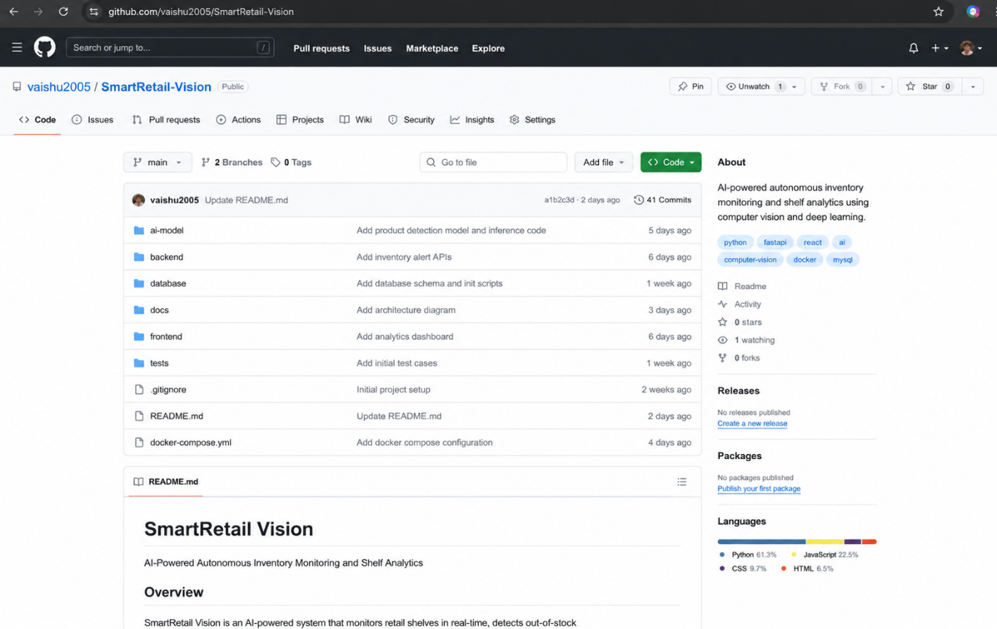

7. Code Review Findings and Recommendations
7.1 Overall Findings
The SmartRetail Vision project addresses an important retail inventory management problem through AI-powered automation.
The proposed system combines computer vision, inventory monitoring, analytics, alerts, and demand prediction into a single solution.
The modular structure supports future expansion, while Git-based version control supports collaborative development.
7.2 Code Quality Recommendations
The following improvements are recommended:
- Maintain consistent coding standards.
- Increase code modularity wherever required.
- Avoid duplicate code.
- Add appropriate error handling.
- Improve inline documentation.
- Use reusable components.
- Perform regular code reviews.
7.3 Repository Recommendations
The repository should be maintained using:
- Meaningful commit messages.
- Feature branches.
- A clean folder structure.
- Proper .gitignore configuration.
- Regular README updates.
- Removal of unnecessary files.
- Clear separation of source code and documentation.
7.4 Testing Recommendations
Testing can be improved by:
- Increasing the number of test cases.
- Adding automated unit tests.
- Performing integration testing.
- Testing incorrect and unexpected inputs.
- Testing AI model accuracy.
- Testing system performance under larger workloads.
- Recording test results systematically.
7.5 Future Enhancements
Future versions of SmartRetail Vision can include:
- Real-time camera-based shelf monitoring.
- Improved object detection accuracy.
- Multi-camera monitoring.
- Advanced demand forecasting.
- Customer interaction analytics.
- Mobile notifications for inventory alerts.
- Cloud-based deployment.
- Integration with POS systems.
- Integration with existing ERP/inventory platforms.
- Advanced business intelligence dashboards.
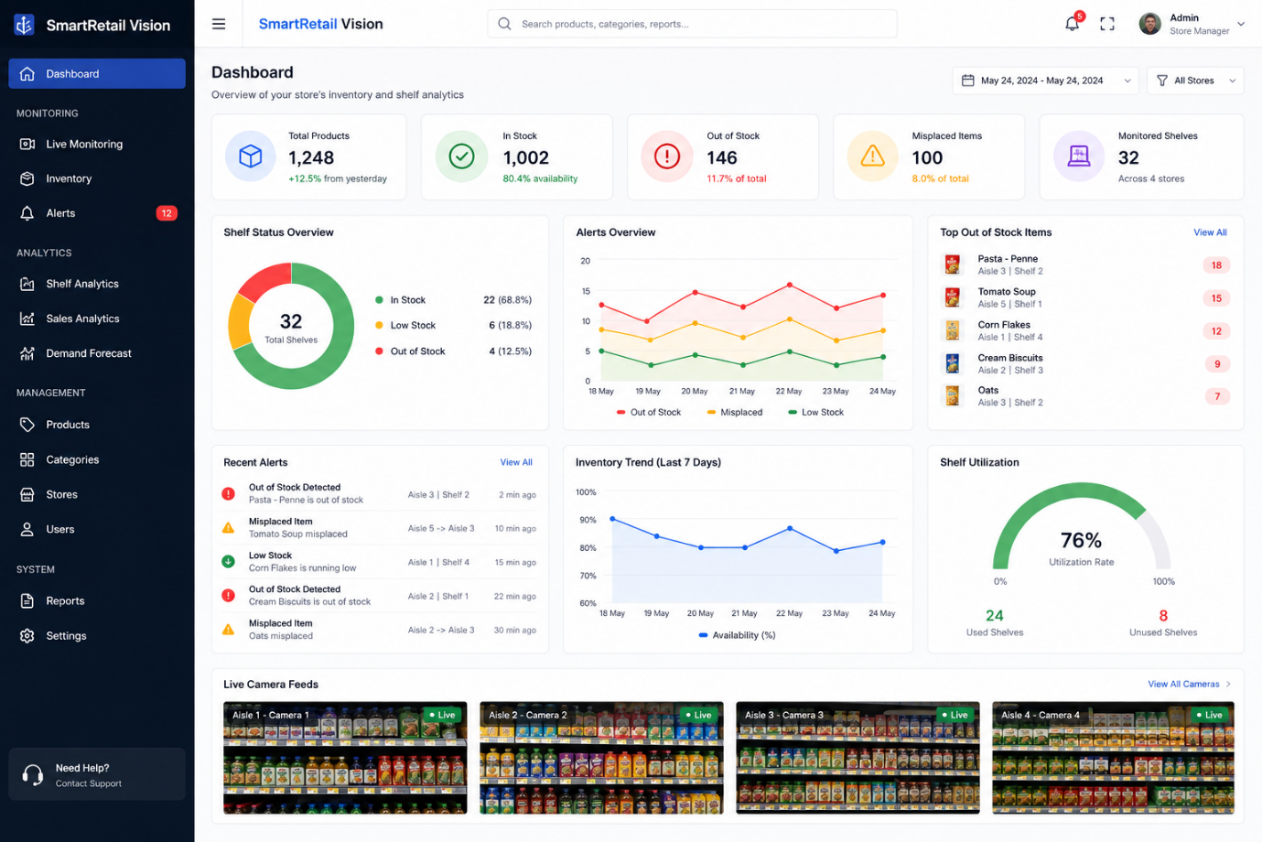

8. Conclusion
SmartRetail Vision provides an AI-powered approach to autonomous inventory monitoring and shelf analytics. The system aims to reduce the limitations of manual shelf inspection by automatically analyzing shelf conditions and identifying stock shortages, empty shelves, misplaced products, and other inventory anomalies.
The project demonstrates how computer vision, deep learning, inventory analytics, and automated alerts can be combined to improve retail operations. Proper repository organization, version control, code quality, testing, and documentation further contribute to the maintainability and scalability of the application.
With additional improvements in AI accuracy, automated testing, real-time camera integration, demand prediction, and retail-system integration, SmartRetail Vision can be extended into a scalable solution for supermarkets, malls, and retail chains.

9. Screenshots to Include in the Report
The assessment specifically expects repository screenshots, code review observations, and test execution evidence.
Include these screenshots:
- GitHub repository homepage.
- Repository folder structure.
- Important source-code file.
- Git commit history.
- Branches page.
- README file.
- Application login page.
- SmartRetail dashboard.
- Shelf image upload/analysis.
- AI product detection output.
- Empty shelf/stock shortage detection.
- Inventory alert.
- Analytics dashboard.
- Test execution/results.
- Architecture/workflow diagram.
Tip: For the strongest submission, replace the generic repository/code/testing descriptions above with evidence from your actual GitHub implementation, because the assessment rubric gives substantial weight to code quality, version control, testing, and repository organization.

